Debouncing in VHDL

Problem
When a mechanical switch or button is pressed, the state of input is not always changed just once. Instead, switch/button may “bounce,” causing contacts to open/close multiple times.

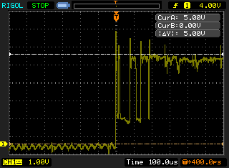
Signal input from switch being turned ON (100us/div)

Solution (VHDL)
Step 1: Store current and last state of input

Step 2: Based on clock frequency (used to sample input) and required period to consider input “stable,” we can calculate the required number of consistent (same state) samples needed to consider the input “stable.”

Step 3: Once the input is stable, pass the state of the input into the rest of the VHDL.

Code (.vhd file on Canvas)

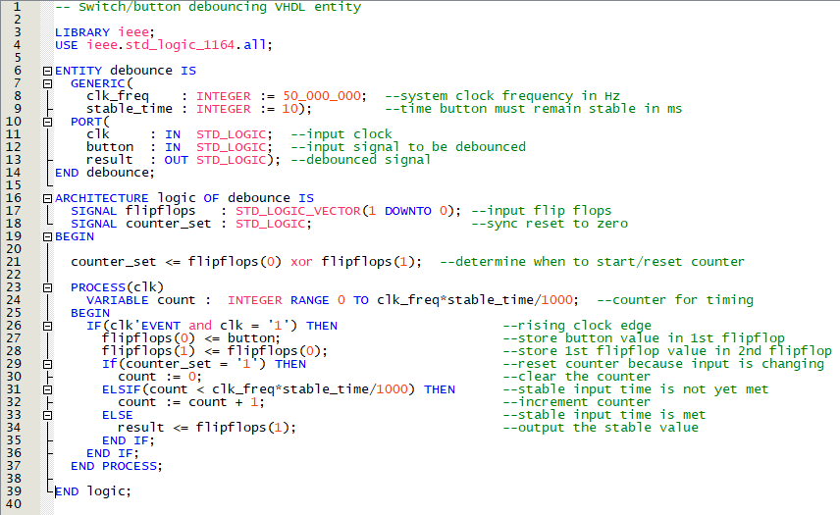
Adding “debounce” to a VHDL Project

- Add the file
  - Project Add/Remove Files in Project
  - Navigate to debounce.vhd, select, and add file to project

- Add the debounce component
  - Recall: COMPONENT should match debounce entity PORT
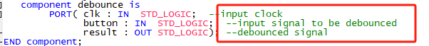

- Debounce inputs using debounce component
  - Recall: PORT MAP – order of arguments must match COMPONENT and entity PORT
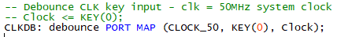

Or

The signal name depends on your own definition

  - For clock input, use 50MHz system clock
    - Declare as input in top-level entity port
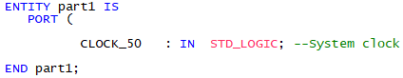
  - In the Pin Assignment Editor, assign input CLOCK_50 to PIN_P11.

